

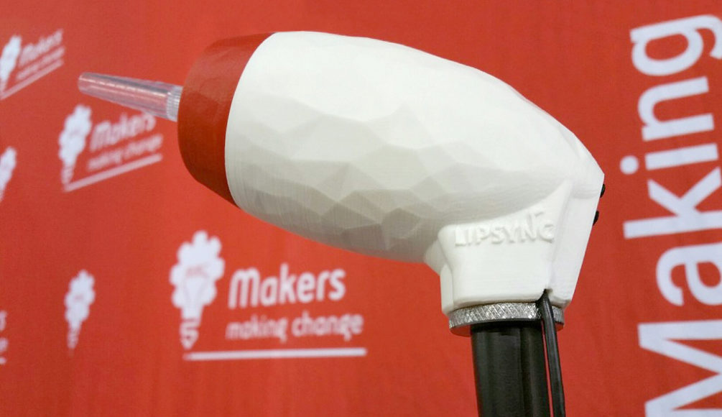

**LipSync**

**Startup Guide**

Version 1.8 / June 2022 www.MakersMakingChange.com

Table of Contents

About the LipSync 3

What Do You Get? 3

Types of LipSync 3

Getting Started 4

Mounting 4

Device Compatibility 5

Powering the LipSync 5

Connecting the LipSync to a Device 6

On-Screen Controls 7

Using the LipSync 8

Functions 8

Speed Control 9

Maintenance 10

Cleaning the Mouthpiece and Filter 10

Cleaning the LipSync Shell 11

Troubleshooting 12

[Joystick Calibration 12](https://neilsquiresoc.sharepoint.com/sites/MMC-RD/Shared%20Documents/Server/AT%20Projects%20-%20Internal/LipSync/Documentation/LipSync_Startup_Guide%20v1.6%20draft.docx#_Toc62462858)

Feedback 13



# About the LipSync

The LipSync is a mouth operated joystick that allows a person who has limited or no control of their hands and arms to control a cursor on a mobile phone, tablet or computer using only head movement. It is an open source assistive technology design by Makers Making Change, a program of the Neil Squire Society that connects volunteer makers with people with disabilities to create more affordable assistive technology.

Open source designs are freely released by their creators for people to make for themselves, modify or incorporate in their own designs for free. Join the Makers Making Change to help people in your community: <http://www.makersmakingchange.com>

Parts of the LipSync

**FRONT VIEW**

**FRONT VIEW**

**BACK VIEW**

**FRONT VIEW**

**Wireless Status LED***Bluetooth status (LipSync Wireless only)*

**LipSync Status LED***ON / OFF, sip & puff modes*

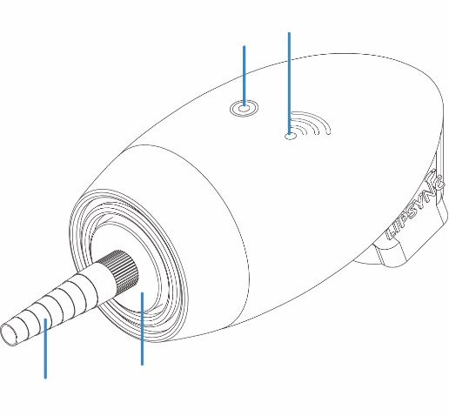

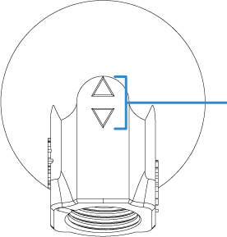

**Speed buttons**  
*Adjusts cursor speed*

**Mounting thread**  
*5/8”*

**Filter***Traps saliva*

**Mouthpiece**  
*Sip-and-puff tubing*

## What Do You Get?

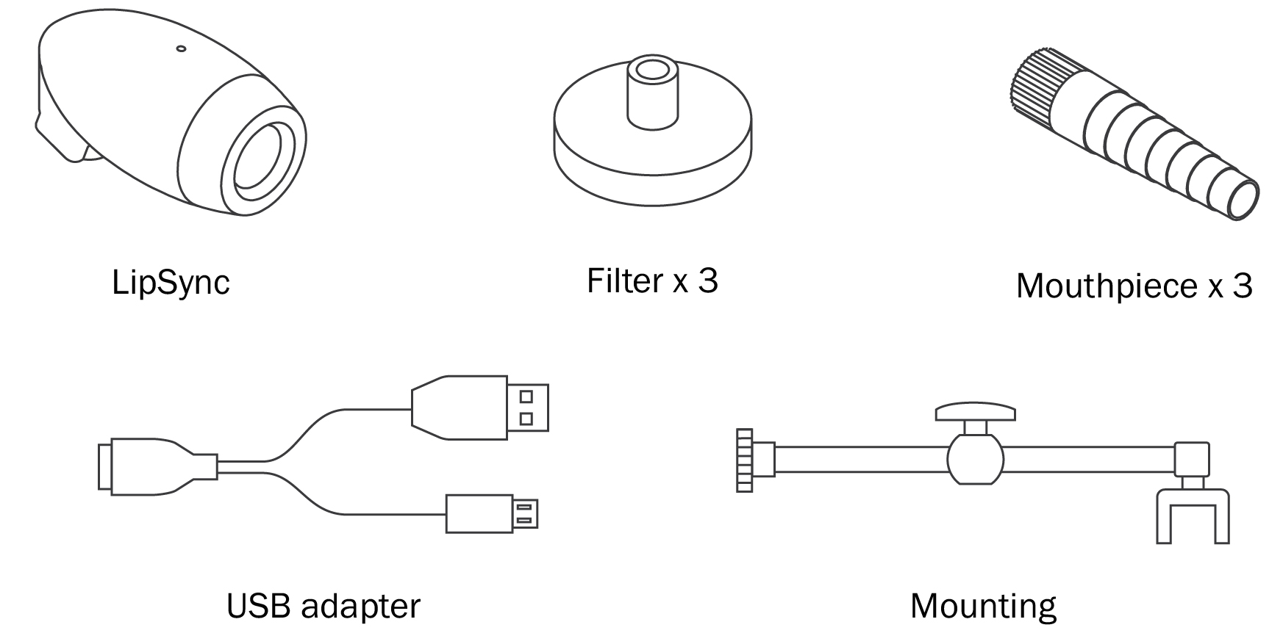

## Types of LipSync

|  |  |  |
| --- | --- | --- |
|  | Description | Connection Type |
| **LipSync** | **Works like a mouse** | **USB** |
| LipSync Wireless | Works like a mouse | Wireless |
| LipSync Macro | Works like a keyboard | USB & wireless |
| LipSync Gaming | Works like a gaming joystick | USB |

# 1 Getting Started

The LipSync requires the following items to get started:

* A LipSync
* Computing device (mobile phone, tablet, or laptop) which supports a USB mouse
* External power bank (optional but recommended)
* Mounting solution for securing the LipSync to a surface

Before plugging the LipSync, make sure of the following:

1. Computing device is fully charged and/or uses an external power source (e.g. power bank).
2. Computing device and LipSync are securely mounted to a stable surface.
3. LipSync USB, adapter cable and external power source are plugged together

## Mounting

Wheelchair: Every wheelchair has different points available for mounting. Common mounting points available on power wheelchairs are the headrest rail, back of wheelchair, armrest rail, under chair cushion, chair rail, and footplate. Try out different areas and see what works best. If you are not familiar with mounts, consult with an assistive technology professional.

Desk: Find a clear space on the front edge of your desk or table. Orient the mount bracket toward the user being careful not to move the LipSync. Secure the bracket and adjust the mounting arm so the LipSync is within easy reach. Tighten the knob when the arm is in the desired position.

Checklist for after mounting:

* Are the clamp and mount secure and do not move?
* Is there clearance around the wheels, wires, and chair frame with the mount attached?
* Does the wheelchair fit through doorways?
* Is the driving view of the user clear with no obstructions?
* Is the mobile device within viewing angle of the LipSync?
* Can the user easily reach the LipSync to use it?

## Device Compatibility

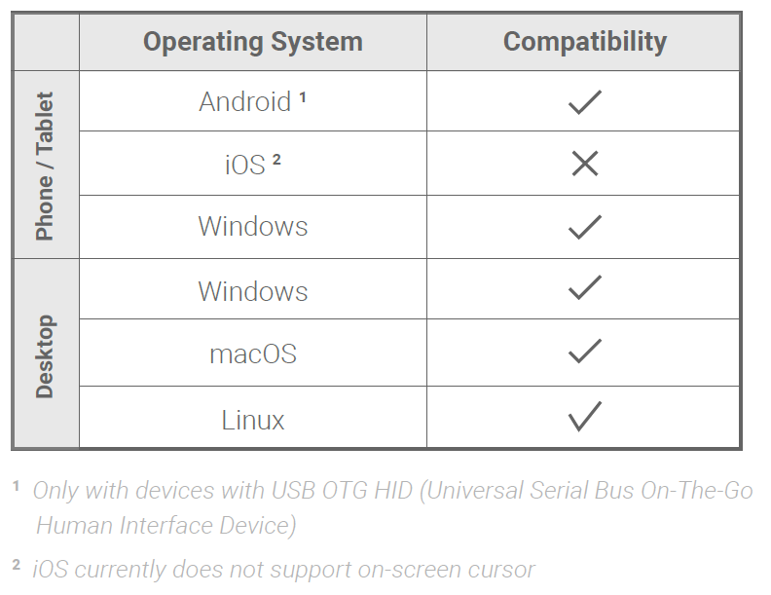Not all mobile phones and tablets support external pointing devices like the LipSync or other mouse replacements. Apple iOS phones and tablets with iOS13 and iPadOS or higher, and most Android and Windows phones and tablets support the LipSync. Check with the manufacturer before purchasing. Look to see if your device supports “USB OTG HID” or “Universal Serial Bus On the Go Human Interface Device” profile.

1 Only with devices with USB OTG HID (Universal Serial Bus On-The-Go Human Interfere Device)

2 Only for iOS13+ and iPadOS. For iOS12 and older, use the *LipSync Macro*

## 

## Powering the LipSync

The LipSync doesn’t have an internal battery so it needs to be powered at all times with an external power source. Users can draw power off of the device (except on iOS devices) or use a power bank (>5000mAH) to prevent the LipSync from drawing battery from device. While using a power bank, power is only supplied to the LipSync and the mobile or tablet will not be charged.

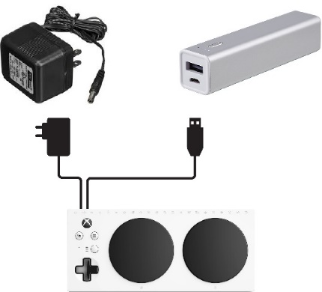

or

Power bank

USB adapter

Device

## Connecting the LipSync to a Device

**Plugging into a Computer, Laptop or Android & Windows Device**

The order in which you connect the USB cables may affect how the LipSync works. Connect the cables in the following order:

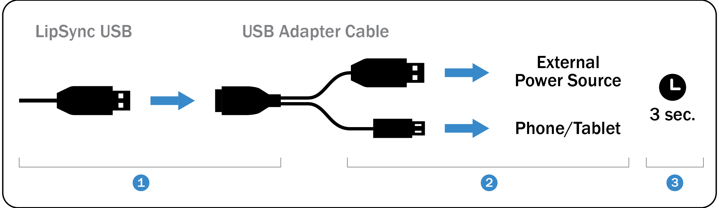

1. Connect the LipSync USB to the USB adapter cable’s receptacle.
2. Connect the other end of the adapter into the computing device and external power source.
3. Wait 3 seconds for the LipSync to initialize. Initialization is complete when the LED blinks red and green four times.

Note: If you are using a desktop or laptop the LipSync USB can be directly plugged into the computer USB port.

**Plugging into an iOS Device**

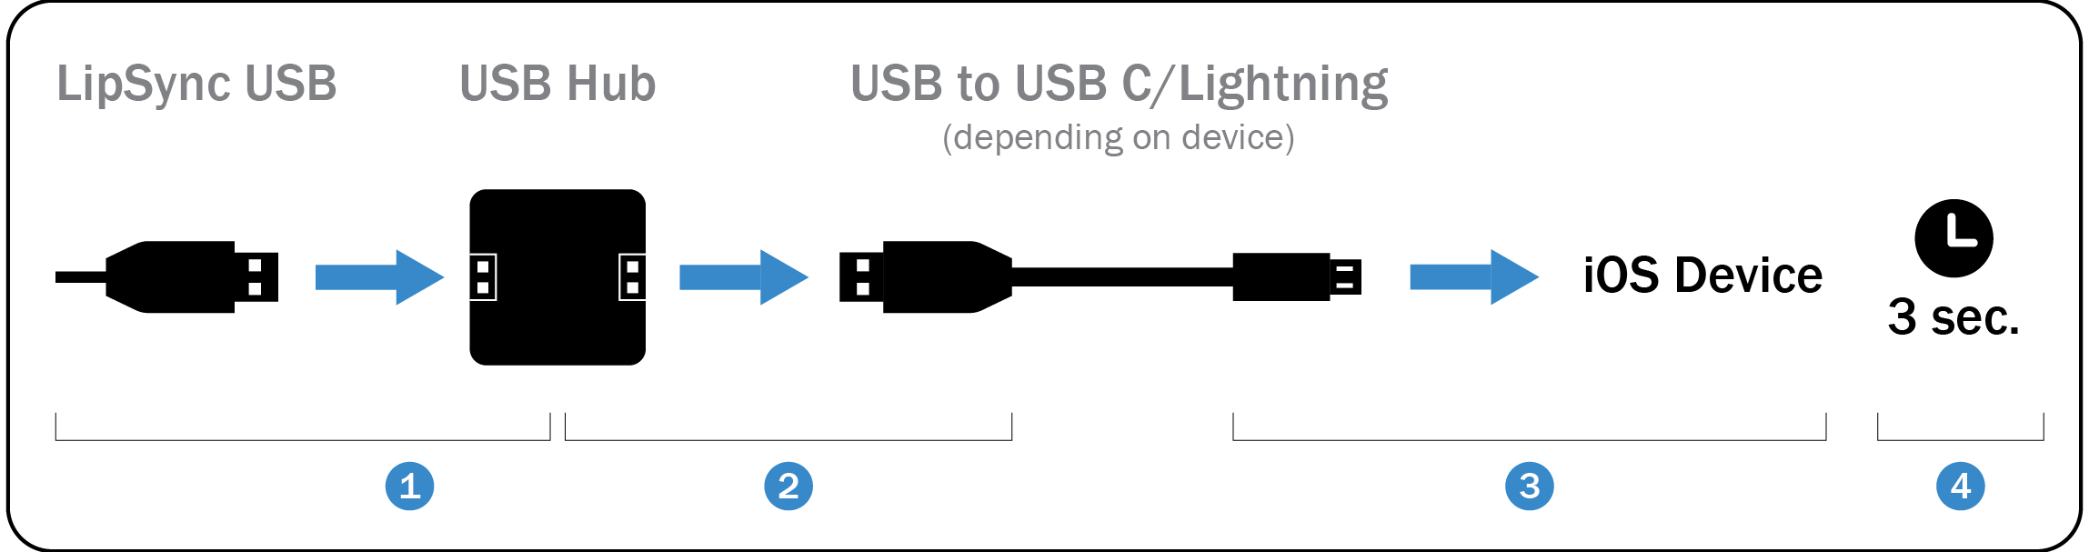

1. Connect the LipSync USB to a USB hub’s receptacle.
2. Connect the USB end of a USB to USB C/Lightning cable into the hub’s USB receptacle.
3. Connect the other end of the USB to USB C/Lightning cable into the iOS device.
4. Wait 3 seconds for the LipSync to initialize. Initialization is complete when the LED blinks red and green four times.

## On-Screen Controls

The assistant menu is a floating onscreen menu that allows access to important functions that cannot be accessed without physically touching the device, like the home button, back, zoom in and out, screen capture, volume, and restart.

**On Android devices**, turn on the Assistant Menu by going to Setting → Accessibility → Dexterity and Interaction → Assistant Menu

**On iOS devices**, turn on AssistiveTouch by going to Setting → Accessibility → Touch → AssistiveTouch

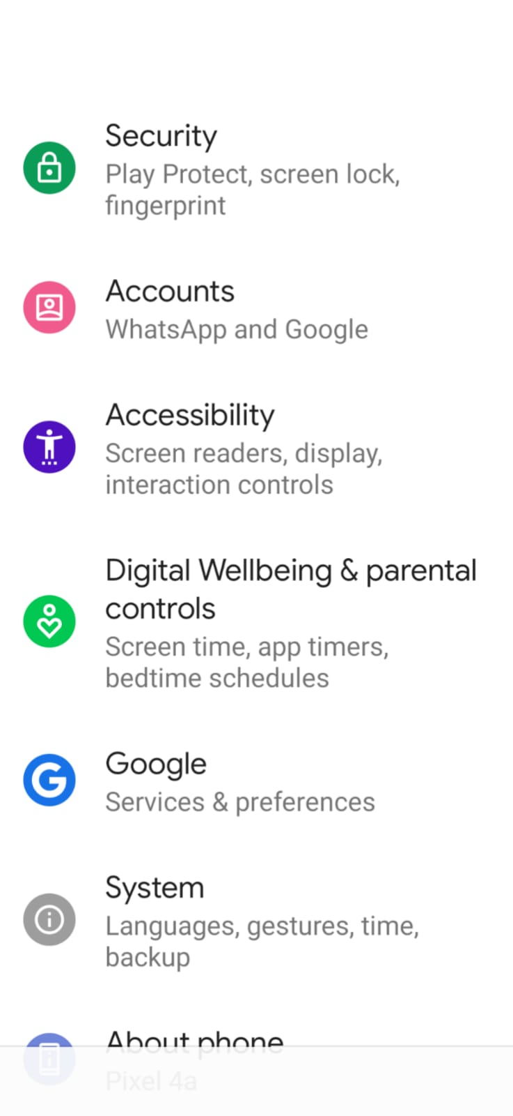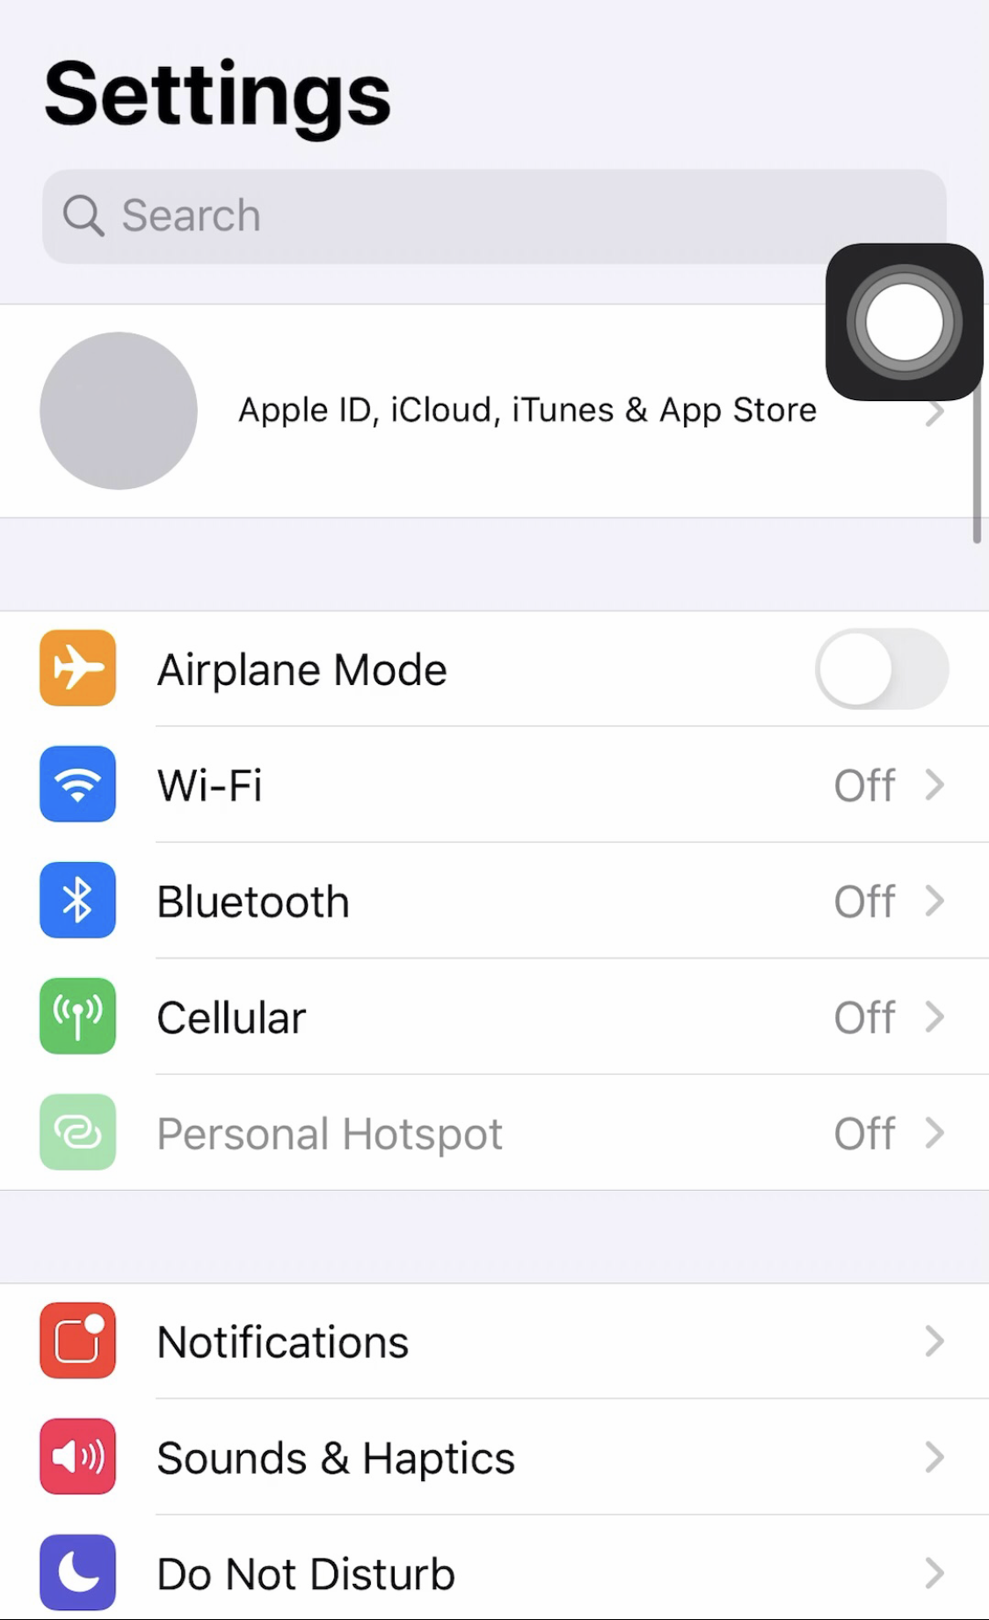

*iOS device*

*Android device*

On some devices, a swiping action is required on some mobile device to unlock it. This can be avoided by setting turning off screen lock. Alternatively, applications such as **Keep Screen On** can be downloaded from the Android Play store to prevent the phone from going to sleep. However, this will drain your phone battery faster.

# 2 Using the LipSync

IMPORTANT: Allow 3 seconds for the LipSync Status LED initialization sequence to flash **each time**the LipSync is connected to a device wihtout moving the mouthpiece. Moving it before the 3 seconds is complete will affect the usage

## Functions

|  |  |  |
| --- | --- | --- |
| **FOR MOBILE DEVICES AND TABLETS** | | |
| **Function** | **Action** | **Time (seconds)** |
| Tap | Puff | 1 |
| Back button1 | Sip | 1 |
| Drag2 | Puff | 3 |
| Scrolling3 | Sip | 3 |
| Cursor home reset | Puff | 5 |
| No action | Sip | 5 |

1 The back/home functions may not work if the device uses on-screen icons. In this case, move   
the cursor over the icon to tap.

2The red LED will stay on at all times in this mode. Deactivate mode by doing a 1 second sip or puff.

3 The green LED will stay on at all times in this mode. Deactivate mode by doing a 1 second sip or puff.

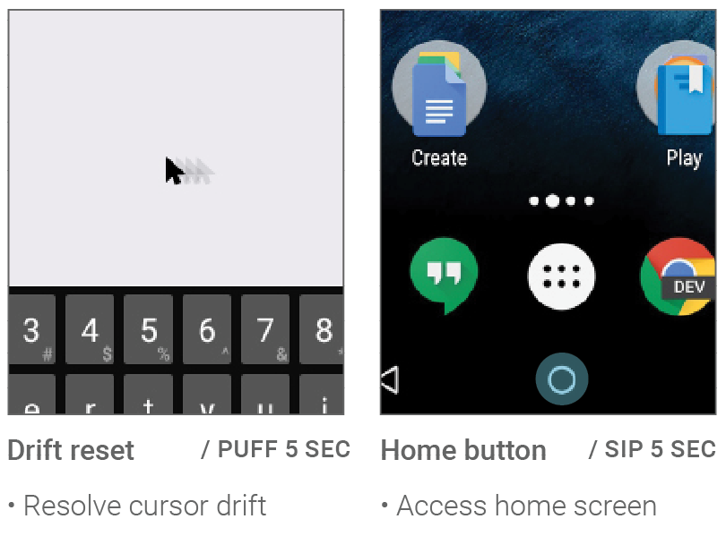**Useful examples:**

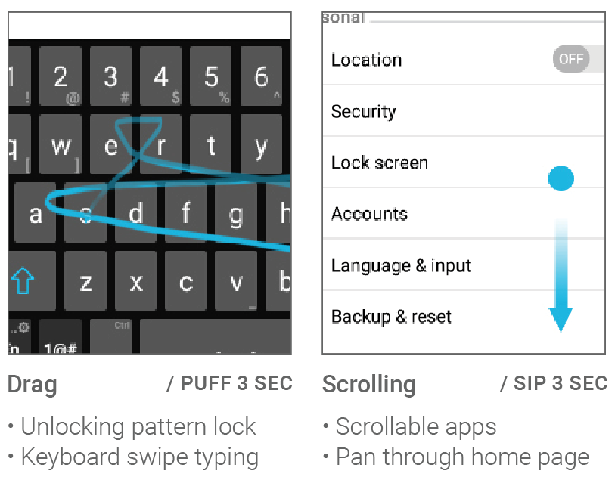

|  |  |  |
| --- | --- | --- |
| **FOR PCs AND LAPTOPS** | | |
| **Function** | **Action** | **Time (seconds)** |
| Left click | Puff | 1 |
| Right click | Sip | 1 |
| Double-click | Puff | 1 each |
| Drag1 | Puff | 3 |
| No action | Sip | 3 |
| Cursor home reset | Puff | 5 |

1The red LED will stay on at all times in this mode. Deactivate mode by doing a 1 second sip or puff.

**Useful examples:**

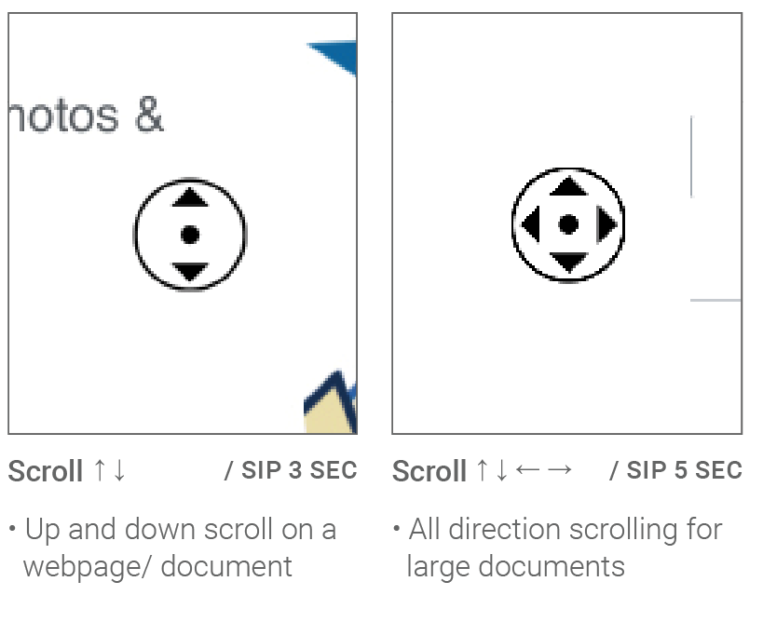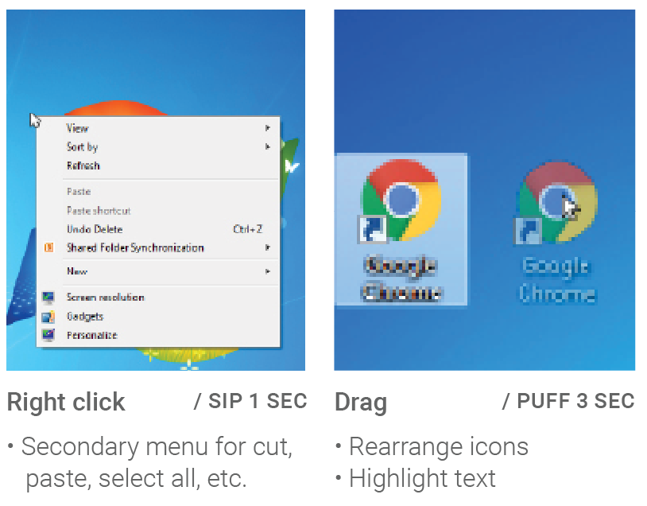

## Speed Control

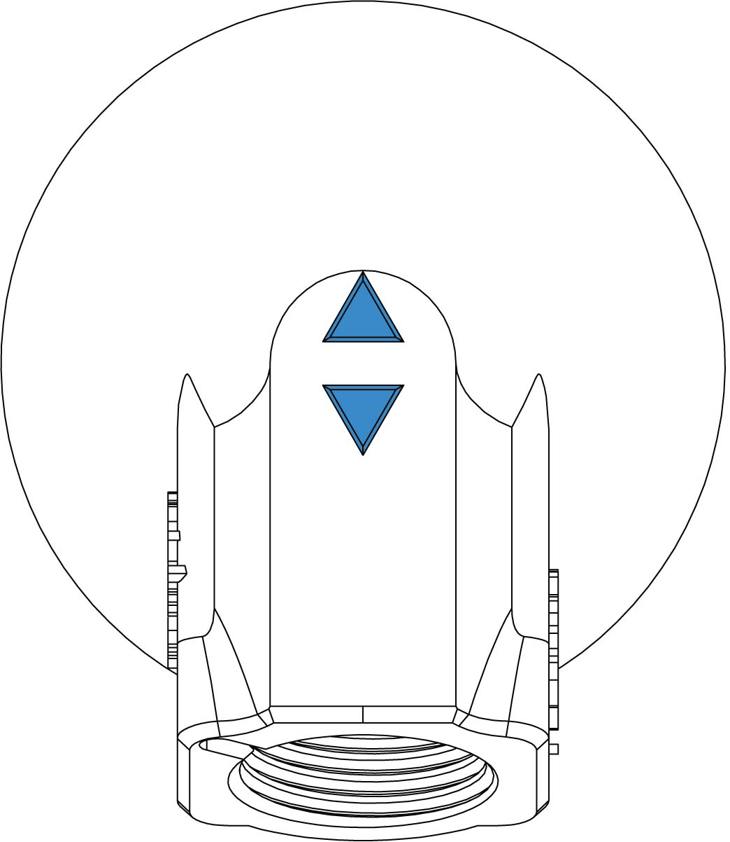The LipSync has 11 speed levels with the default level set to 5 when first set up. The LipSync Status LED will blink the cursor speed level number.

Press the button to increase the cursor speed

Press the button to decrease the cursor speed.

To adjust the cursor sensitivity and speed, set the device’s cursor speed to its slowest setting to start then adjust the LipSync speed control buttons. If it’s still not fast enough, gradually increase the speed on the device.

***LipSync back view***

# 3 Maintenance

## Cleaning the Mouthpiece and Filter

Each user should have their own set of mouthpiece and filter for hygienic reasons. These pieces are made of acrylic plastic and have a 3-6 month life cycle depending on the usage. Keep unused pieces in a clean sealable bag out of the sunlight.

Follow these steps to clean the pieces during its life cycle:

1. With the LipSync facing you and wearing clean gloves, twist the mouthpiece and filter **counter clockwise** to detach it. If you’re having trouble removing the filter, see the next page.  
   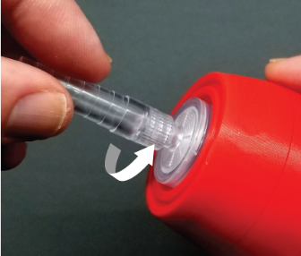 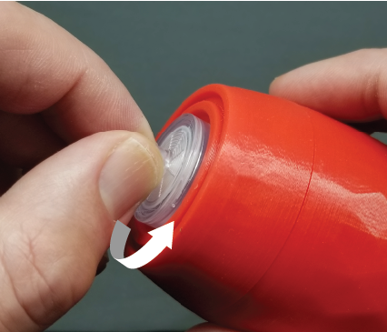
2. **To clean the mouthpiece:** mix 1 cup (250 mL) of water with 2 tsp (10 mL) of 5% bleach (sodium hypochlorite). Soak the mouthpiece for 10 minutes and then air dry or wipe with a clean cloth.

**To clean the filter:** throw away used filters that have trapped saliva and use a clean piece.

1. Wearing clean gloves, twist the mouthpiece and filter **clockwise** until finger tight. Do not overtighten.  
   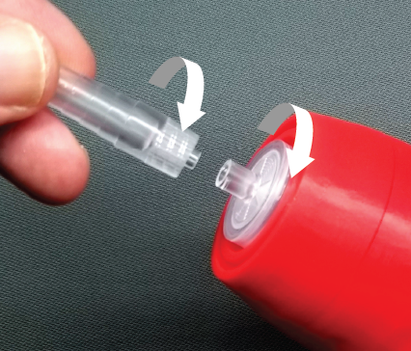 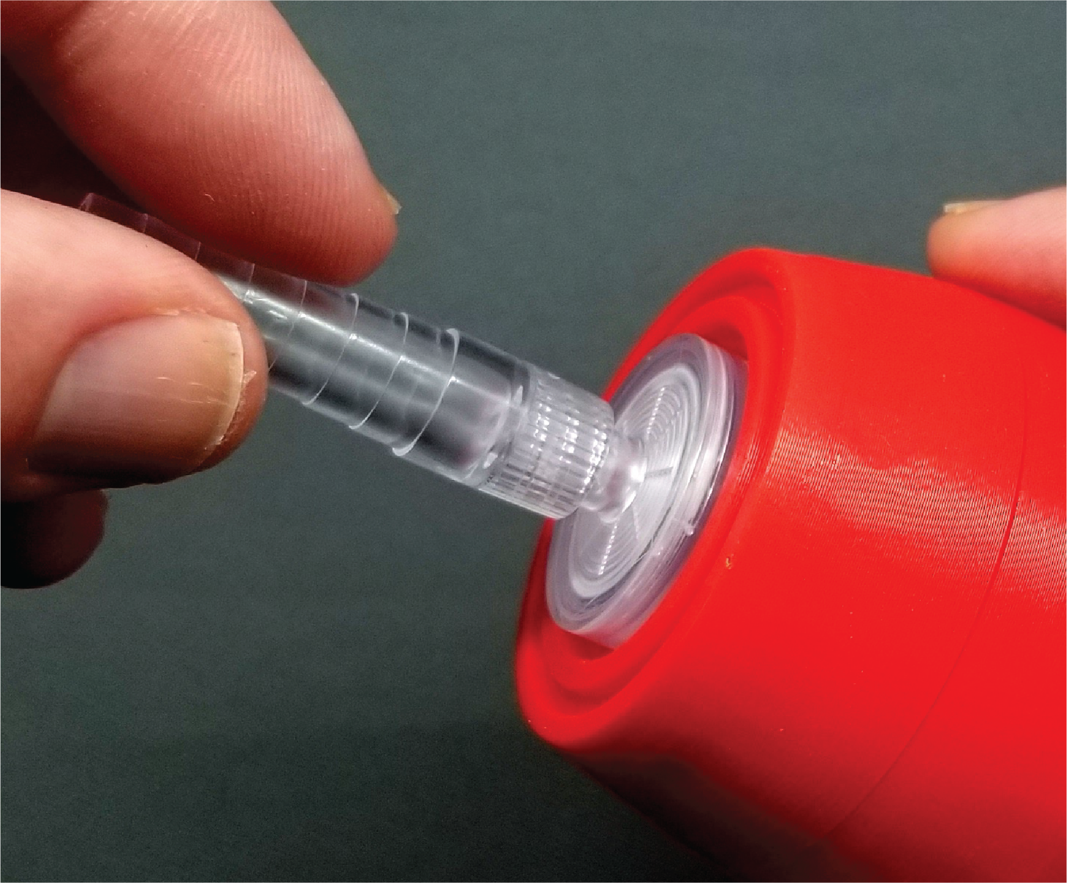

#### Broken stem removal

If you’re unable to screw in a new LipSync air filter, it may be because a portion of the old filter has broken off and is stuck inside the air fitting. To remove this broken piece, the best tool to use is a medical hemostat or very small vice grips. You can also use fine nose needle nose pliers, however, you’ll need to be more careful with pliers so as not to not to break the plastic and make the problem worse.

**To remove using a hemostat:** Insert one side of the hemostat tip into the middle of the broken off filter stem and the other side of the tip to the outside of the protruding broken stem. Be extra careful not to grip on the outside of the fitting that it’s in or you will damage the LipSync. Squeeze the handle on the hemostat until the teeth between the finger holes lock. Finally, rotate the tip of the hemostat counter-clockwise to remove the broken stem.

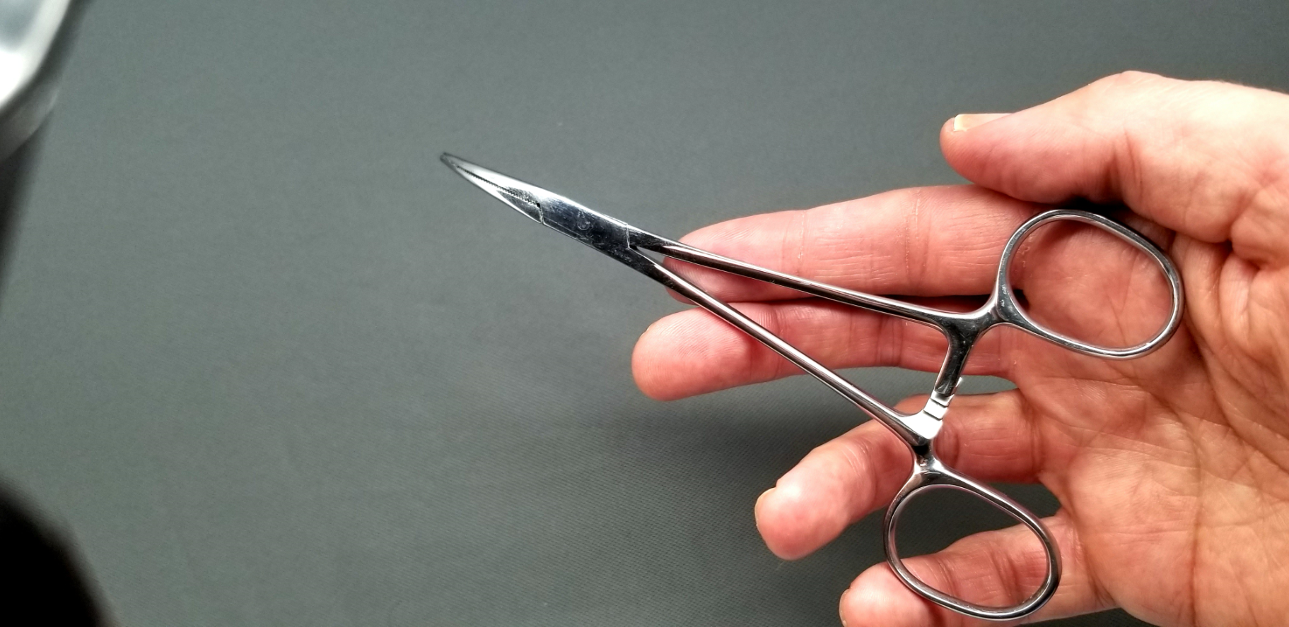 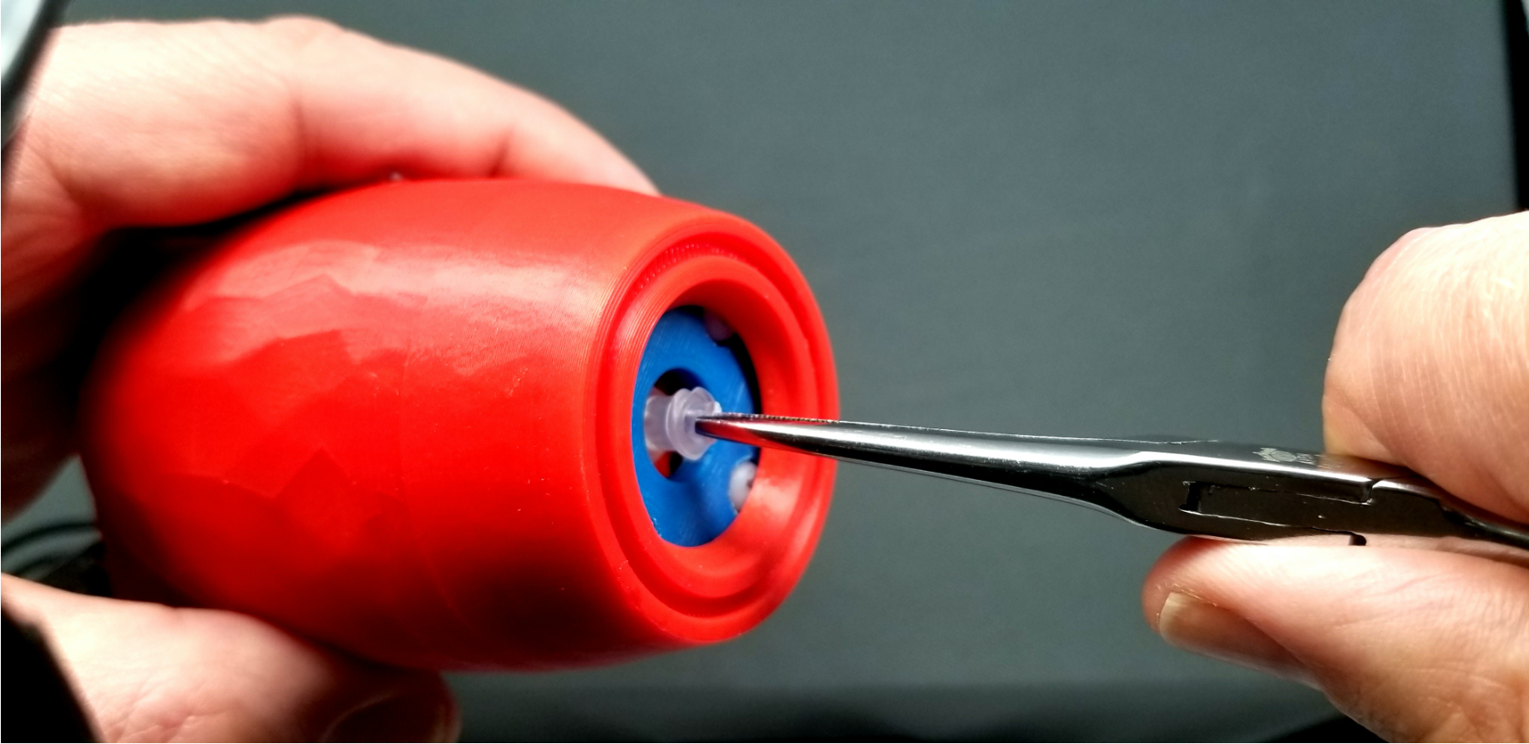

If a hemostat is not available, use an extra fine tip needle nose pliers or vice but be even more careful as these larger tools can damage the LipSync easily.

## Cleaning the LipSync Shell

* Wipe with a non-abrasive cloth lightly dampen with water or cleaning alcohol
* Don’t use abrasive cleaning materials.
* Don’t soak the LipSync shell in any cleaning solutions

# 4 Troubleshooting

If the cursor drifts, doesn’t move in one direction, or behaves inconsistently, try these steps in the following order:

1. Perform a 5 second puff for the cursor home reset.
2. Unplug the LipSync USB from the power source (e.g. power bank or device), wait a few moments before plugging back in, and let the LipSync initialize.
3. Perform the joystick calibration. Follow the video tutorial here: <http://tiny.cc/CalibrateLipSync>

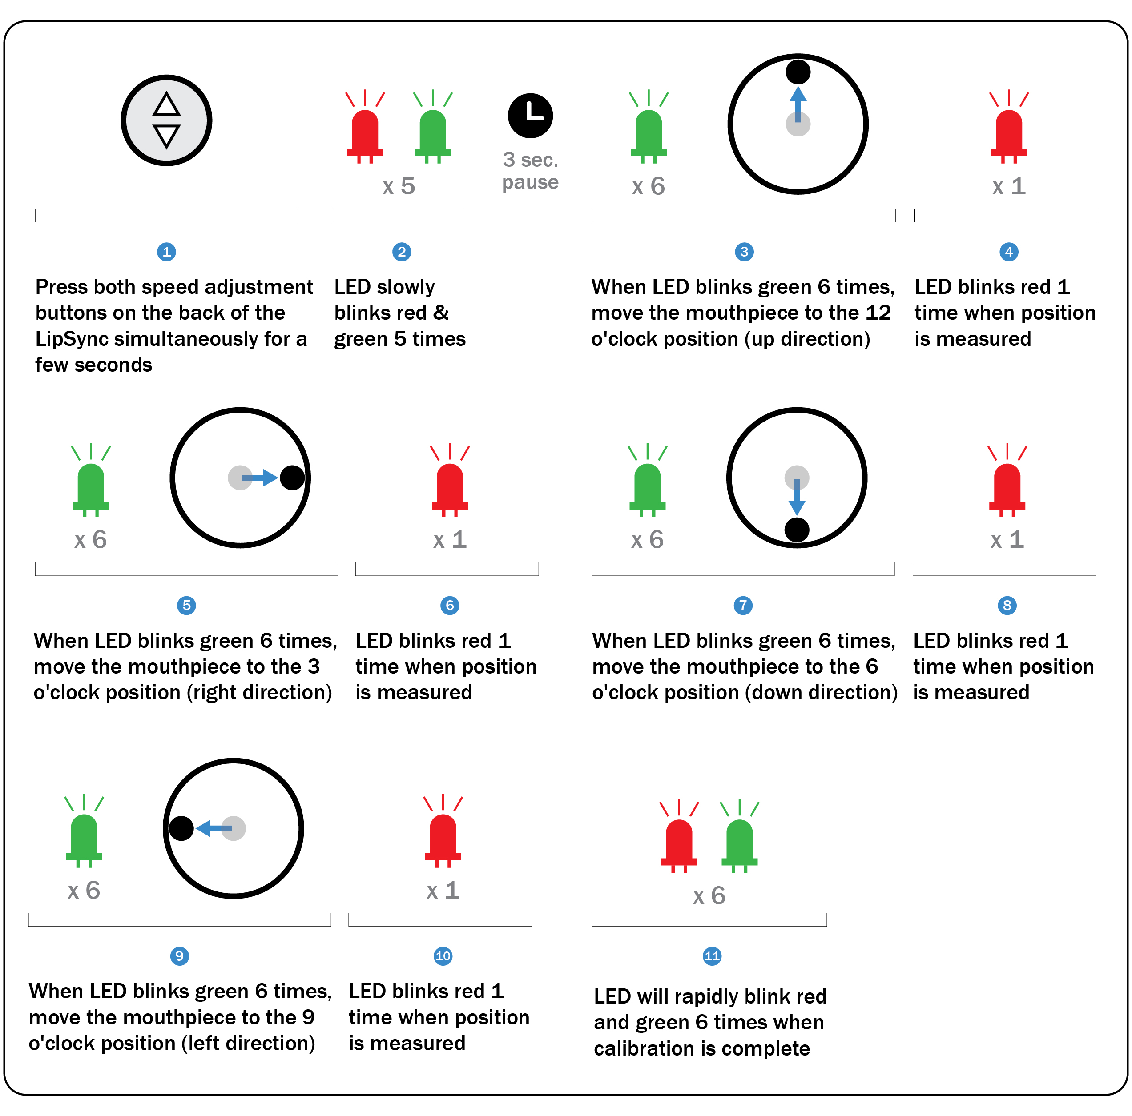

## Joystick Calibration

# 5 Feedback

The LipSync is an open-source project, which means that anyone and everyone is able to build the device and improve upon the design. If you have suggestions for how to improve the LipSync or require technical help, please reach out using one of the following routes:

1. Contact your LipSync maker
2. Makers Making Change Forum (<https://makersmakingchange.com/forum/>)
3. Leave a review on the LipSync page (<https://www.makersmakingchange.com/project/lipsync/>)